Experiment worksheet

6.1 All organisms are interdependent

Pages 102–103 and 198

Challenge 6.1: Studying food webs

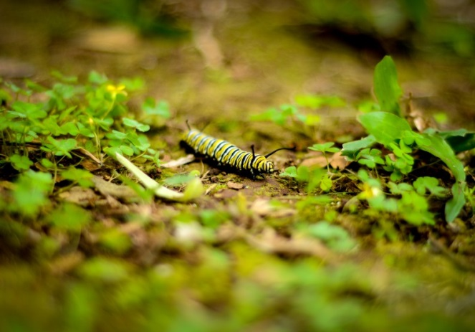What you need:

metre-long sticks, metric rulers, poster board, markers, photographs of ecosystems

What to do:

1 Think about what you know about food webs in your area. Write a list of at least 10 components within these food webs. Do some areas support more life than others?

2 Select two 1 m2 areas in your backyard, schoolyard or neighbourhood to study. The study areas should be near each other but in two different habitats (e.g. on a footpath and on some grass, or just inside a forest and in a clearing).

3 Observe and record all organisms in the area above and within this study area.

• Which organisms are producers?

• Which organisms are consumers?

• How do the numbers (of individuals and species) of producers and consumers compare?

Experiment worksheet

6.2 All organisms have a role in an ecosystem

Pages 104–105 and 199

Experiment 6.2: What if water were filtered through a pot with native grasses?

Aim

To find out how effective natural systems can be at filtering water.

Materials

• 1 medium-sized plastic pot

• 2 plastic buckets

• Stopwatch

• Gravel

• Sand

• Soil

• Plants

• Mixture of castor oil, soil, small pieces of paper, water, salt water

• Native grasses

Method

1 A few weeks in advance, prepare one plastic pot with a layer of gravel, then sand and finally soil. Plant some native grasses in this pot. Wait until the grasses have established themselves in the pot before proceeding.

(Hint: You should be able to see the roots of the plant in the bottom of the pot.)

2 Mix the castor oil, dirt, finely shredded paper, salt and any other materials you wish to include in a bucket of water. The mixture should be very cloudy and have an odour.

3 Slowly pour an equal amount of the mixture through the pot, using the second bucket to collect the solution that filters out of the base of the pot. Time and record the flow of solution out of the base of the pot. Also take note of the odour of the solution.

Inquiry: What if the water was filtered through a pot with no plant?

1 Write a hypothesis for your question.

2 What (independent) variable will you change from the first method?

3 How will you measure if the absence of the plant makes a difference to the filtering of the water?

4 How will you make sure that all parts of the plant are removed?

5 What other variables will you need to control?

Results

In the space below create a table to record the time taken for the solution to flow out of the base of each pot. Include a description and/or photograph of the appearance of the solution before and after it has gone through each pot.

|  |
| --- |
|  |

Discussion

1 Did the solution flow out of each pot at a different rate? Suggest a reason for any differences observed.

2 Compare the cloudiness of the final solutions. Suggest a reason for the differences observed.

3 Compare the odour of the filtered solution with that of the original mixture.

Conclusion

How effective are natural systems at filtering?

Experiment worksheet

6.2 All organisms have a role in an ecosystem

Pages 104–105 and 199

Challenge 6.2: Exploring leaf litter

Leaf litter is the dead and rotting leaves that lie on the ground under trees and in gardens. Leaf litter helps protect soil and is home to many tiny, fragile invertebrates that work together to keep the soil in good condition.

**BEFORE** YOU START, ASK YOUR TEACHER ABOUT ANY BULL ANTS, POISONOUS SPIDERS OR CENTIPEDES IN YOUR AREA. THERE MAY BE SOME ANIMALS THAT COULD BITE YOU. IF IN DOUBT, LEAVE ANIMALS ALONE AND ASK YOUR TEACHER.

What you need:

old newspaper, gloves, plastic test tubes or specimen tubes with lids, wet paintbrush, hand lens, pen, paper

What to do:

1 Find an undisturbed area approximately 50 cm long by 50 cm wide. Work only in this area.

2 Lift up the leaves slowly. Use your brush to pick up the tiny animals and make sure not to crush them.

3 Make a list of the animals you find. Make a separate list for eggs, cocoons, larvae or types of fungi.

4 Return the animals to the place where you found them.

• Why is it important to know about the animals you are likely to find before looking for them?

• Why should you return animals to the place where you found them?

• A leaf litter community doesn’t contain any producer organisms, such as healthy green plants. What is the energy source for this community?

• How does this leaf litter community help the soil?

Experiment worksheet

6.3 Food webs can be disrupted

Pages 106–107 and 200

Experiment 6.3: What if the effectiveness of pollinators were reduced?

Aim

To examine factors that affect the pollination of fruit.

Materials

• 10 chairs

• 2 large bags of popcorn

• 10 paper bags

Method

1 Divide the class into groups with six students in each group. Each group represents a team of bees.

2 Gather the bees in one corner of the room or on the oval. This is the bee hive.

3 Place approximately ten chairs around the room or oval to represent apple trees. On the seat of each tree, place one handful of popcorn and an empty paper bag.

4 The bees must fly from tree to tree, taking a single piece of popcorn from one tree and putting it in the paper bag of another tree. This represents a bee pollinating the apple trees. Twenty seconds represents one growing season. This can become a competition if the number of pieces of popcorn on each tree is controlled.

5 At the end of 20 seconds, the bees gather back in the hive. A representative counts how many pieces of popcorn they have in each paper bag. Each piece of popcorn represents one apple that was able to grow on that tree during the season.

6 Record how many apples are grown in each team’s first season. Average the number of apples grown that season across all the teams.

7 Empty the paper bags and reset the popcorn on each chair tree.

Inquiry: What factors can affect the effectiveness of pollinators?

Choose one of the variations below to investigate.

• What if the weather becomes colder so that the bees fly more slowly?

• What if a harsh winter kills half the bees in the hive?

• What if overcrowding in the hive causes half the bees to swarm out of the area?

• What if the apple trees are damaged and lose half their leaves?

• How will you represent your independent variable in the pollination model?

• What effect do you expect to see on your dependent variable?

• What variables will you have to control in your inquiry?

Results

In the space provided, draw up an appropriate table and graph to show the results of your inquiry.

|  |
| --- |
|  |

Discussion

1 What effect did changing bee populations have on the amount of fruit produced?

2 Suggest one way your pollination model was not an accurate depiction of real-world pollination.

3 Suggest one way to improve the model you used.

4 Name one situation that scientists may use computer modelling to research.

Conclusion

How important are pollinators to the supply of fruit?

Experiment worksheet

6.4 Human activity can affect local habitats

Pages 108–109 and 201

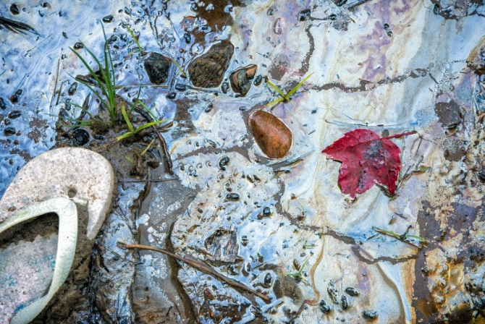Challenge 6.4: Calculating your ecological footprint

Ecological footprint calculators are online surveys that help you and your family compare the impact of different activities you do or decisions you make.

1 Search the Internet for an ecological footprint calculator. Calculate the ecological footprint for your home or school.

2 Calculate your greenhouse gas emissions and the impact of your car, if your family owns one.

• What things can you do at home to live more sustainably?

• What changes would you have to make to your home to live more sustainably?

• What changes would you and your family have to make to your lifestyles to live more sustainably?

• Will these changes eventually save you and your family money?

Experiment worksheet

6.6 Environments can be responsibly managed

Pages 112–113 and 201

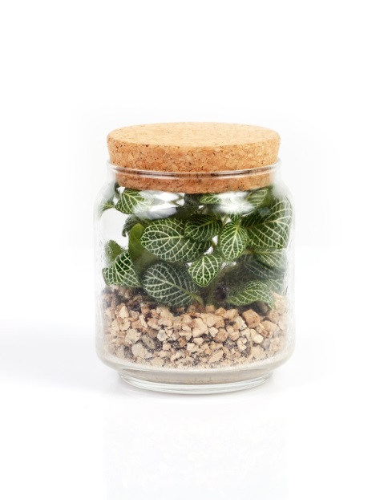Challenge 6.6: Making a biosphere

Design brief

Use what you have learnt in this unit to construct a stable ecosystem for aquatic plants and macroinvertebrates (water fleas or pond snails).

Criteria restrictions

• Your materials are limited to those you find in a school pond or those provided by your teacher.

• A 1-litre bottle should be recycled for this challenge.

Questioning and predicting

• How will you place each organism in the container?

• What quantities of each organism should you use?

• What role will each organism play in your ecosystem?

• How will you prevent spillage from the container?

• Where will you store your container? How often will you evaluate the health of your organisms?

• What will you do if you find your organisms are unable to survive in the environment you create?

• What is the primary source of energy for the food webs in your ecosystem?

Processing, analysing and evaluating

1 What was the most successful feature of your design? What was the least successful?

2 Is there any practical use for your design?

3 If you were doing this experiment again, how would you modify your design? Explain.

Communicating

Present the various features of your design in a detailed poster.

Experiment worksheet

6.7 Modern land managers use traditional Indigenous techniques

Pages 114–115 and 202

Challenge 6.7: Looking at eucalypt adaptations

What you need:

nuts, leaves and bark of a eucalypt

What to do:

1 Place the nuts in a 40ºC oven for 24 hours to open and shed their seeds. Each of these thick woody capsules contains hundreds of tiny seeds.

• Why is the seed of the gumnut protected with such a thick external capsule?

• What might trigger the release of the seed from the gumnut?

2 Feel the leaves of the eucalypt. They have a thick cuticle that is effective in preventing water loss.

3 Hold a leaf up to the light or under a binocular microscope. Notice the numerous small dots, which are oil glands in the leaf.

• What is the function of the oil glands in a eucalypt leaf?

4 Have a close look at the bark of the tree. Many eucalypt trees have a bark that is thick and fibrous.

• What are some of the functions of bark?